PRACTICAL 10:
Program1:
Code:
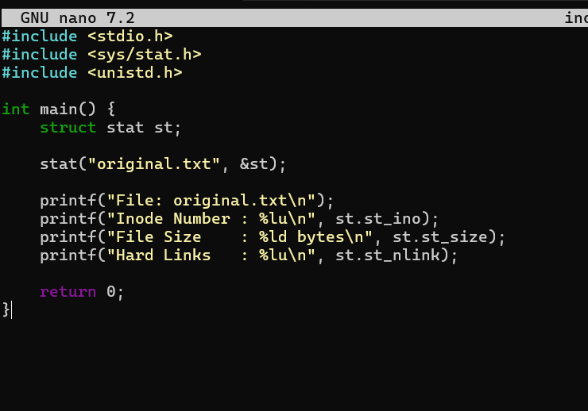
Output:
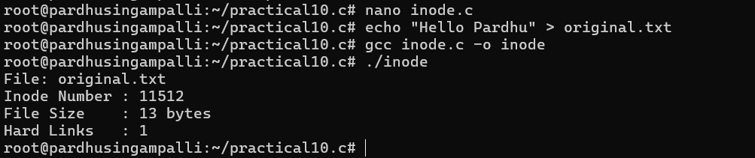

Program 2:
Code:
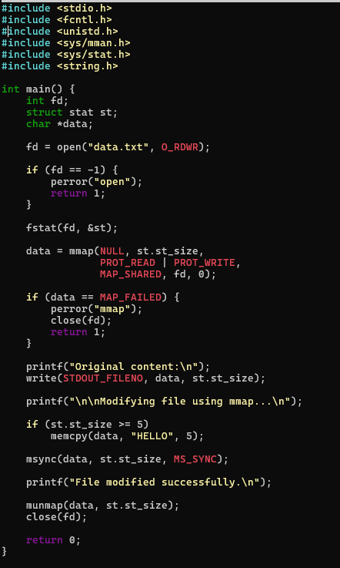
Output:
